**A Project Report on**



**Kamani Science & Prtaprai Arts College,Amrel**

**Girls Hostel Management System**

**Developed by**

**Pethani Madhuri(5009)**

**Babariya Dhruvika(5011)**

**Guide by**

**Mr. Rakesh Savaliya**

**Submitted in partial fulfillment of the requirement For the**

**award of the degree of Bachelor of Computer Applications (BCA)**

**Year of Submission**

**2020-2021**

**Saurashtra University-Rajkot**



**Preface**

The main objective of any computer science student is to get practical knowledge as possible. Being able to have a practical knowledge by developing a project is a lifetime experience. As practical knowledge is important as theoretical knowledge we are thankful of having a project.

Through the development of the project we had a great experience of various strategies that can be applied in development of the project. This project is the stepping stone for our career.

We are pleased to present this project report. Proper case has been taken while organizing the report so that it is easy to comprehend. Also, various software engineering concepts have been implemented.



**Acknowledgement**

We are student of BCA sem-5 Studying in the Kamani Science College, Amreli. We Thanks to the entire person who has given their support in shaping of the system.

We thanks Mr.Rakesh Savaliya for giving us guidance and Co-operation in understanding the system. We also thanks them for their unconditional help in making of this project.

We have great deal of gratitude towards our head of department who encourage us in taking up this activity. We thank all faculties and administrative staffs of the institute.

Thanks to all !!

**Pethani Madhuri**

**Babariya Dhruvika**

**Index**

| No | Title | Page No |
| --- | --- | --- |
| 1 | **Introduction** | **5** |
| 2 | **TimeLine Chart** | **6** |
| 3 | **Project Profile** | **7** |
| 4 | **Hardware Requirement** | **8** |
| 5 | **Software Requirement** |  |
| 6 | **Requirement Specification** | **9** |
| 7 | **Problem Definition** | **10** |
| 8 | **Project Planning & Scheduling** | **11** |
| 9 | **System Analysis** | **12** |
| 10 | **Project Page Structure** | **15** |
| 11 | **Data Dictionary** | **16** |
| 12 | **Data Flow Diagram** | **23** |
| 13 | **ER – Diagram** | **27** |
| 14 | **Use case Diagram** | **25** |
| 15 | **Activity Diagram** | **30** |
| 16 | **Screen Shot** | **32** |
| 17 | **Bibliography** | **52** |

 **Introduction**

The online girls hostel management system is web base software to provide college student accommodation to the university hostel more efficiently.

This project also keeps details of the hostellers and applied students. It is headed by warden. He will be the administrator. For accommodate large number of students into hostel.

This document is intended to minimize human works and make hostel allocation is an easier job for coast students and hostel authorities by providing online application for hostel, automatically select the students from the waiting list and mess calculation, complaint registration, notice board etc.

Students will get approval notification in their mails. Hostellers can view notice board, hostel fee, mess menu by login into the online system.



**Time Line Chart**



**Project Profile**

| * Project Name | : Hostel Management System |
| --- | --- |
| * Developed by | : Pethani Madhuri  Babariya Dhruvika |
| * Front End Tool | : PHP,HTML,JavaScript,Dreamwear |
| * Back End tool | : MySQL |
| * Operating System | : Microsoft Windows Xp &Microsoft Window 7 |
| * Computer System | : Pentium-IV or Higher, RAM: 256 MB |
| * Completion Time | : 3 Months |
| * Guide by | : Mr. Rakesh Savaliya |
| * Submitted by | : Saurashtra University, Rajkot |



**Hardware Requirement**

* 512+ MB of RAM
* Multimedia Keyboard And Mouse
* 1.0+ GHz Processor
* Monitor
* 32X CD Drive



**Software Requirement**

* Operating System
* Front End Tools
* Back End Tools
* Documentation Tools
* Browser specification



**Requirement Specification**

1. MySQL RDBMS used to maintain the all concerned data.
2. Uses special views to display data.
3. Display all types of data using classified reports with combinations of multiple tables.
4. Special searching of Hostel management in website.
5. Controlling the information regarding whole network site.

**Problem**

There are a lot of drawbacks in keeping and maintaining a hostel. Especially with a manual system. Since most hostels are being run by only one hostel manager, the number of students in a room are sometimes not known by the officer. He has to go room by room to ensure that a room is occupied or not. Sometimes people may be owing in the hostel and they are saved on papers or huge notebooks, and sometimes receipts. If the books should go missing or stolen, one would never be able to know if a student is owing or not. Room allocation also becomes a problem as the officer might not know which rooms are available or not. And some hostels have a lot of rooms or have mare storey and it would be very tedious to go through all storey in search of a free room for an applicant. Also the officer might not know the number of students in a room or know if a room is full or not.

**Project Planning & Scheduling**

Social networking is a recent invention that has the Internet still at the edge of its seat due to its popularity with people. This is mostly because it really is for the people. Bringing every kind of social group together in one place and letting them interact is really a big thing indeed.

Before selecting of this subject, I have found its routine and most common problems like Communication with high cost, No Builds Credibility, No Connections, and Time Consuming. Now these days the communication is so fast and users want to fast communicate with his/her friends and create their own video, blog, album and photo album and share with friends. I hope the project itself says more. The scheduling is given as under.

**System Analysis**

System analysis is the process of identification of objectives and requirements, evaluation of alternative solutions and recommendation for a more feasible solution. In other words, system analysis is the step by step process of gathering, recording and interpreting facts. The main aim of analysis is to determine problem areas and to take solutions to reduce or eliminate them.

* System analysis itself breaks into two stages:
  1. **Preliminary analysis**
     1. **Detailed analysis**

During analysis, data are collected from the available files, decision points and transactions of the systems using various tools like Data Flow Diagram (DFD).



**Feasibility Study**

A purpose of feasibility study is to check out the possibility of a computerized solution to the organization’s observed problem before very much money that has been spent on.

A feasibility study is carried out to select the best system that meets performance requirements. Only by spending the time to evaluate the feasibility do I reduce the chances for extreme embarrassment at later stage of the system project.

For the complete feasibility study I need to concentrate on following area:

They are of Three types:

1. Technical
2. Operational
3. Economical

* **Technical**

Technical feasibility considers whether the desired project can be completed within the framework of available technology. As our project was website designing, this was not much of a problem, as many advanced web-editing tools are available.

* **Operational**

Operational feasibility was done to assure that the product that would be developed would be used. Since a cards and gifts has to have a website of its own sooner or later, that wasn’t much of a problem.

* **Economical**

Our Commercial Website is Economically Feasible Because. We have developed this website only for one time. Only future enhancement is required on the other hand every client can view our site any time or many time as per their requirement. So the future economical expenses are null. So we can say that this website is totally economically feasible.



**Project Page Structure**

* **Client Side:**

**Client Side**

**Home**

**Rules**

**Login**

**Booking**

**Gallery**

**About Us**

**Facilities**

**Register**

**Contact Us**

* **Admin Side:**

**Admin Side**

**Home**

**Login**

**Employee manage**

**manage**

**manage**

**Setting**

**Logout**

**Add Course Detail**

**Add Notice Detail**

**View Payment**

**Add Cost Detail**

**View Register**

**Student manage**

**Add Room & Block Detail**



**Data Dictionary**

The Data Dictionary is a set of Tables. MYSQL uses it to maintain information about is own databases.

* **Data Dictionary contains the following information.**
  + Name of the table of databases.
  + User information such as privileges.
  + Names and data-type of all columns in database tables.

**Database Name: hostel.sql**

1. **user :** This table is used to store user information.

| Field | Type | Null | Key |
| --- | --- | --- | --- |
| Serial | int(20) | No | Primary |
| Email | varchar(50) | No |  |
| Fname | varchar(30) | No |  |
| Lname | varchar(30) | No |  |
| Mno | int (10) | No |  |
| Gender | varchar(30) | No |  |
| City | varchar(30) | No |  |
| Uname | varchar(30) | No |  |
| Password | varchar(50) | No |  |

1. **booking:** This table is used to store booking student information.

| Field | Type | Null | Key |
| --- | --- | --- | --- |
| Bookid | int(100) | No | Primary |
| fullname | varchar(100) | No |  |
| Dob | date | No |  |
| Photo | varchar(200) | No |  |
| Email | int (100) | No | Unique |
| password | varchar(30) | No |  |
| cpassword | varchar(30) | No |  |
| Gender | varchar(10) | No |  |
| Category | varchar(50) | No |  |
| Cellno | int(10) | No |  |
| fathername | varchar(50) | No |  |
| fathercellno | int(10) | No |  |
| mothername | varchar(50) | No |  |
| State | varchar(50) | No |  |
| City | varchar(50) | No |  |
| Pincode | int(6) | No |  |
| Preadd | varchar(100) | No |  |
| parmadd | varchar(100) | No |  |
| nameofinst | varchar(50) | No |  |
| Course | varchar(50) | No |  |
| Doj | date | No |  |
| Blockno | varchar(50) | No |  |
| Roomno | varchar(50) | No |  |
| Seatno | varchar(50) | No |  |
| Duration | varchar(50) | No |  |
| Fees | int(20) | No |  |
| Isactive | varchar(1) | No |  |

1. **payment:** This table is used to store payment information.

| Field | Type | Null | Key |
| --- | --- | --- | --- |
| Id | int(20) | No | Primary |
| cardholdername | varchar(100) | No |  |
| cardnumber | Int(100) | No |  |
| e_month | varchar(100) | No |  |
| e_year | varchar (100) | No |  |
| Cvv | varchar(100) | No |  |
| Total_pay | int(10) | No |  |
| Bookid | int(20) | No |  |

1. **admin :** This table is used to store admin information.

| Field | Type | Null | Key |
| --- | --- | --- | --- |
| Id | int(20) | No | Primary |
| Username | varchar(50) | No |  |
| Password | varchar(50) | No |  |

1. **blocks :** This table is used to store block information.

| Field | Type | Null | Key |
| --- | --- | --- | --- |
| Serial | int(20) | No | Primary |
| Blockno | varchar(50) | No |  |
| blockname | varchar(50) | No |  |
| Isactive | varchar(1) | No |  |

1. **rooms :** This table is used to store room information.

| Field | Type | Null | Key |
| --- | --- | --- | --- |
| Serial | int(20) | No | Primary |
| Roomno | varchar(50) | No |  |
| Blockno | varchar(50) | No | foreign key |
| Isactive | varchar(1) | No |  |

1. **seats :** This table is used to store seat information.

| Field | Type | Null | Key |
| --- | --- | --- | --- |
| Serial | int(20) | No | Primary |
| Seatno | varchar(50) | No |  |
| Blockno | varchar(50) | No | foreign key |
| Roomno | varchar(50) | No | foreign key |
| Isactive | varchar(1) | No |  |

1. **amount:** This table is used to store amount information.

| Field | Type | Null | Key |
| --- | --- | --- | --- |
| Serial | int(20) | No | Primary |
| Duration | varchar(100) | No |  |
| Amount | int(100) | No |  |

1. **cost:** This table is used to store cost information.

| Field | Type | Null | Key |
| --- | --- | --- | --- |
| Serial | int(20) | No | Primary |
| Type | varchar(100) | No |  |
| Amount | decimal(18,2) | No |  |
| insert date | timestamp | No |  |
| Description | varchar(100) | No |  |
| Costbilldate | date | No |  |

1. **course:** This table is used to store course information.

| Field | Type | Null | Key |
| --- | --- | --- | --- |
| Serial | int(20) | No | Primary |
| Fullname | varchar(100) | No |  |
| Shortname | varchar(50) | No |  |
| Date | timestamp | No |  |

1. **employee:** This table is used to store employee information.

| Field | Type | Null | Key |
| --- | --- | --- | --- |
| serial | int(100) | No | Primary |
| name | varchar(100) | No |  |
| emptype | varchar(100) | No |  |
| gender | varchar(10) | No |  |
| dob | Date | No |  |
| mobile | int(10) | No |  |
| address | varchar(150) | No |  |
| doj | Date | No |  |
| designation | varchar(50) | No |  |
| salary | decimal(18,2) | No |  |
| blockno | varchar(50) | No |  |
| isactive | varchar(1) | No |  |
| photo | varchar(200) | No |  |

1. **empsalary:** This table is used to store employee salary information.

| Field | Type | Null | Key |
| --- | --- | --- | --- |
| serial | int(20) | No | Primary |
| name | varchar(100) | No |  |
| monthyear | varchar(50) | No |  |
| amount | decimal(18,2) | No |  |
| date | Date | No |  |

1. **notice:** This table is used to store notice information.

| Field | Type | Null | Key |
| --- | --- | --- | --- |
| serial | int(20) | No | Primary |
| title | varchar(100) | No |  |
| description | varchar(500) | No |  |
| createddate | Timestamp | No |  |



**Data Flow Diagram**

The DFD gives brief idea on how the designed system is working. It also suggests to us the type of users who using this system and the process involved in the system.

**Represent Entity**

**Represent Process**  **Represent Data Store Represent Flow Line**

**Represent a Decision**

 **Context Level**

**Student**

**Fill Register Form**

**Login**

**Successfully Login**

**Check Registration**

**Successfully Register**

**Check Login**

**Confirm Data**

**Admin**

**Confirm Login**



**Student 1st Level**

**1.0**

**Login**

**Get Login Check Login**

**1.1**

**Register**

**1.2**

**Booking**

**1.3**

**Payment**

**Student**

**Login**

**Successfully Login Confirm Login**

**Fill Booking Send Data**

**Form Booking ````**

**Confirm Form**

**Send Data Payment View Receipt Generate Receipt**

**Admin 1st Level**



**1.0**

**Login**

**1.3**

**View Block & Room**

**1.4**

**View Employee**

**1.2**

**View Payment**

**1.1**

**View Student**

**Admin**

**Get Login Check Login admin**

**Successfully Login Confirm Login Provide Booking fill Data booking Submit Data**

**View the Data**

**Payment fill Data**

**payment view the Data Submit Data**

**Request to view Add/Edit/Delete**

**Data Data**

**Response room Replay Add/Edit/Delete**

**Request to View Data Data employee**

**Response Replay**

 **ER Diagram**

**Blocks**

**Has**

**Rooms**

**Seats**

**Has**

**Booking**

**Has**

**Payment**

**Use-case Diagram**

**User Admin**

**Activity Diagram**

* + - **Client side**

**Register**

**Login**

**Invalid**

**Check Username &Password**

**Valid**

**Home**

**Register**

**Login**

**Gallery**

**Logout**

**About Us**

**Payment**

**Contact as**

Contact **as**

* **Admin side**

**Login**

**Invalid**

**Check Username &Password**

**Valid**

**Home**

**Student**

**manage**

**Employee**

**manage**

**Add Cost**

**Detail**

**Logout**

**Add Notice**

**Detail**

**Add Room**

**Detail**

**Add Course**

**Detail**

Contact **as**

**Screen Short**

* **Admin**

**Login**

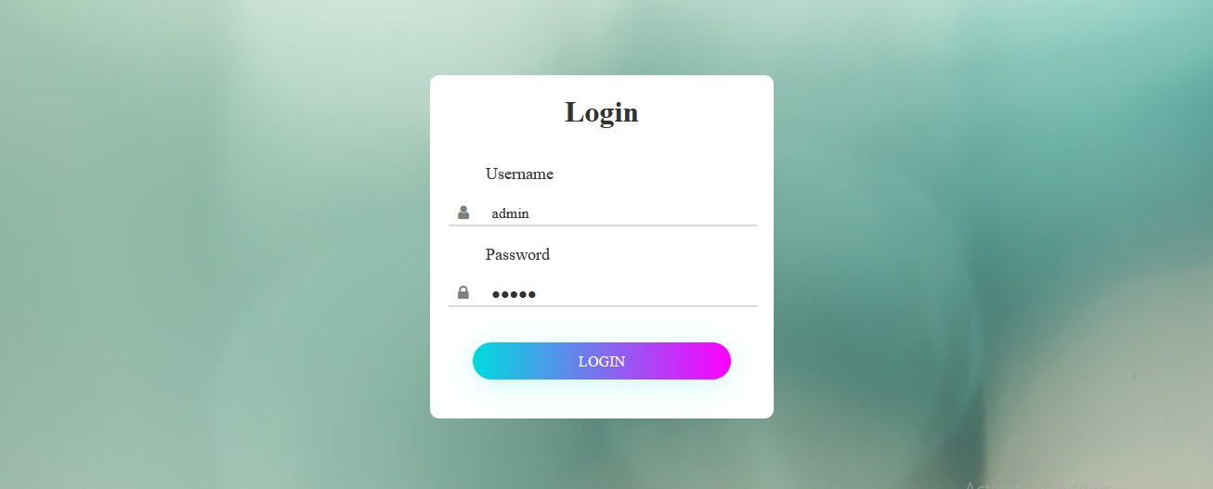

**Dashboard**

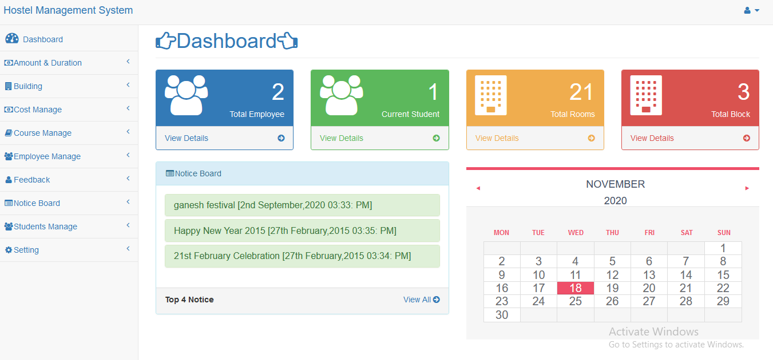

**Amount**

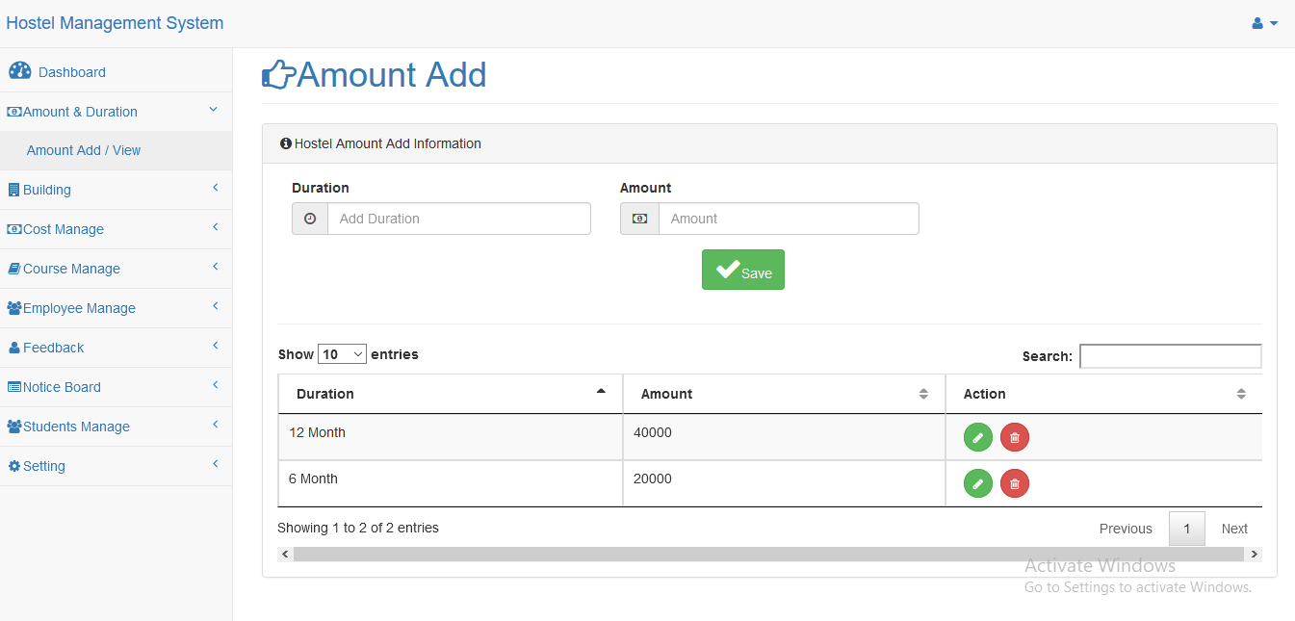

**Blocks**

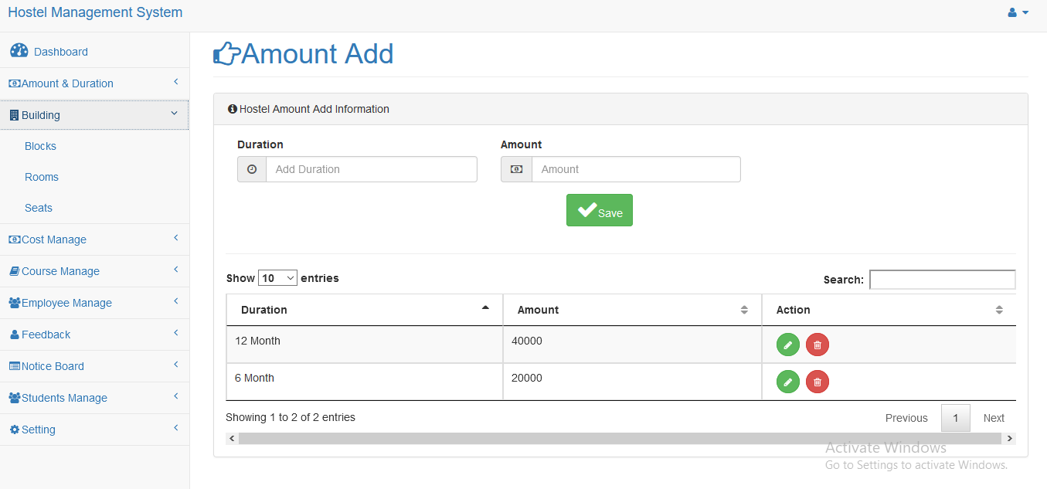

**Rooms**

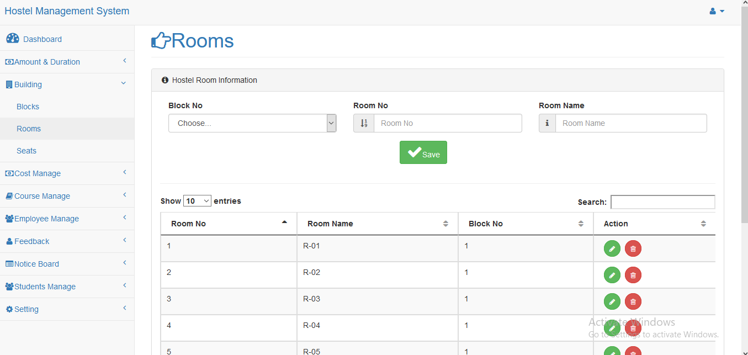

**Seats**

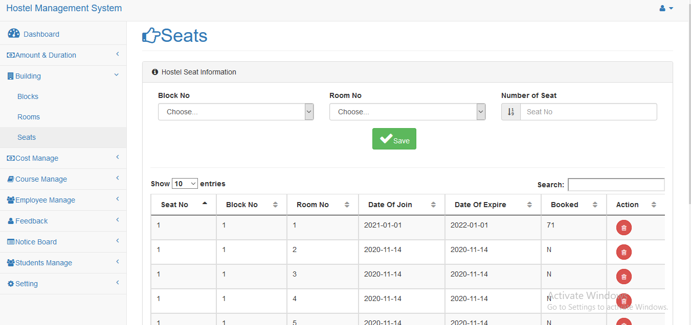

**Cost Add**

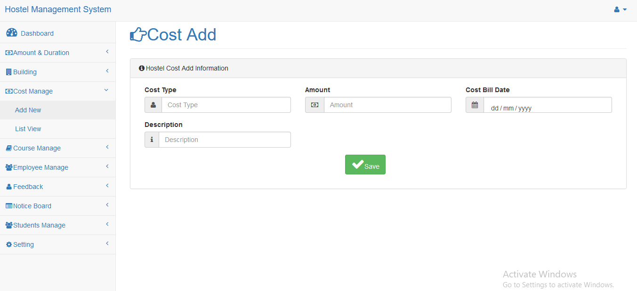

**Cost view**

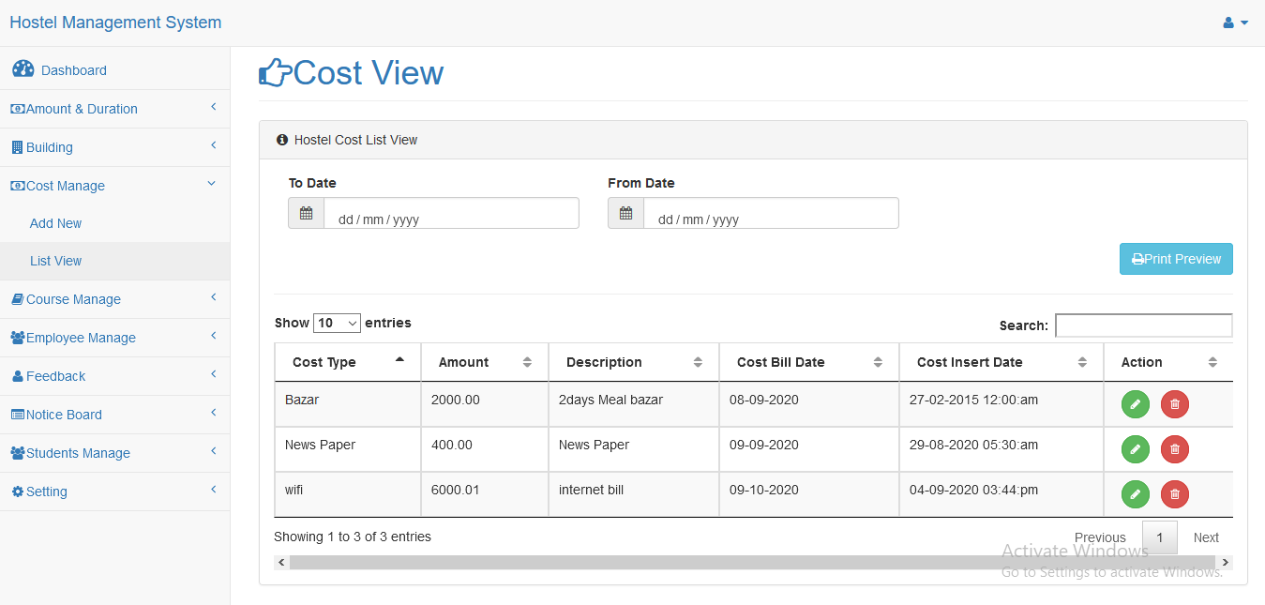

**Course**

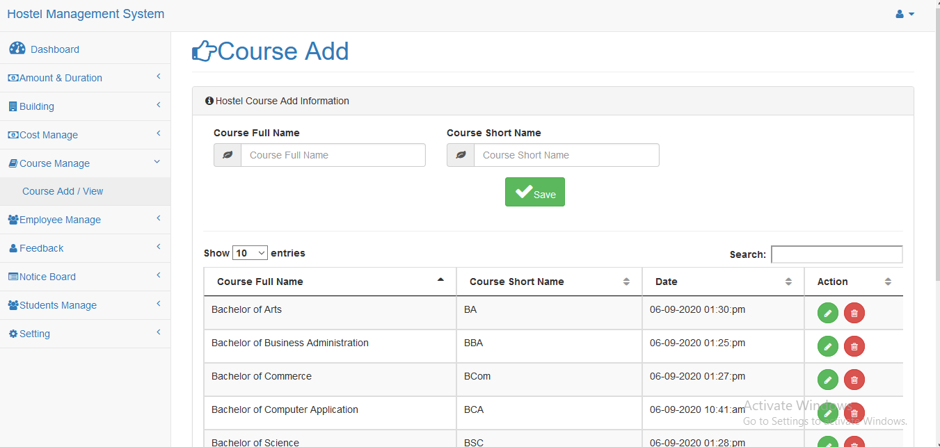

**Employee add**

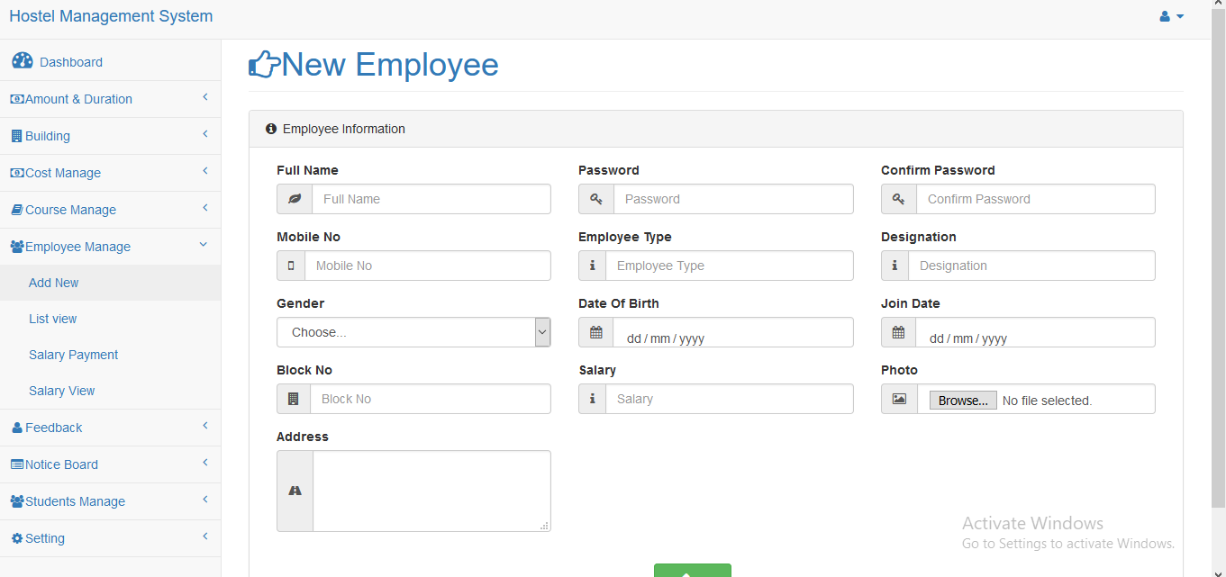

**Employee view**

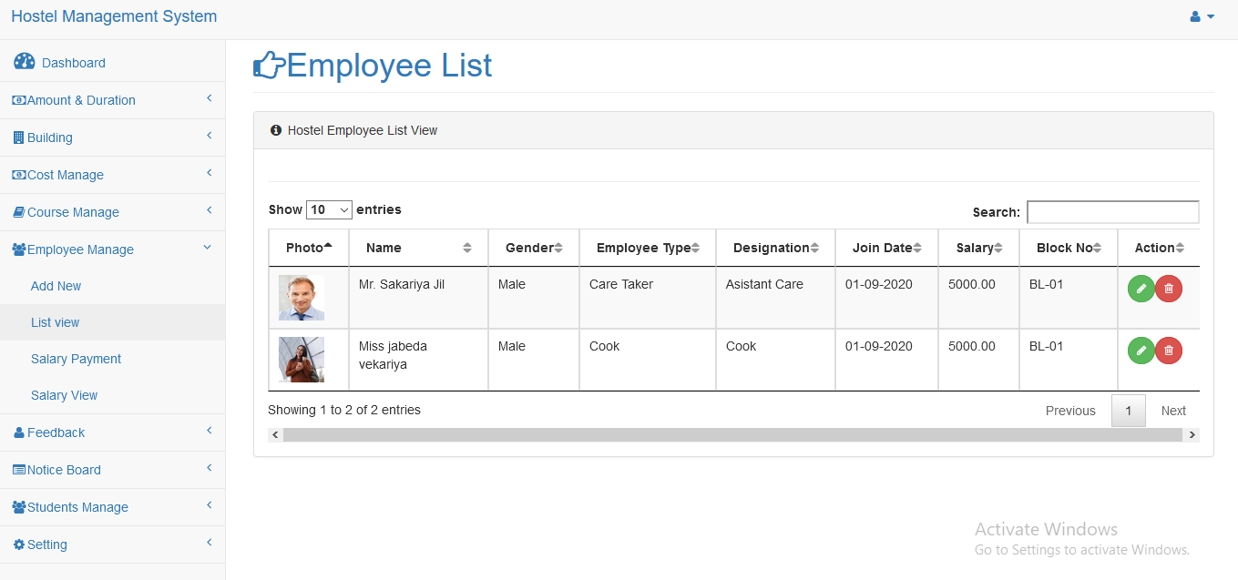

**Employee salary payment**

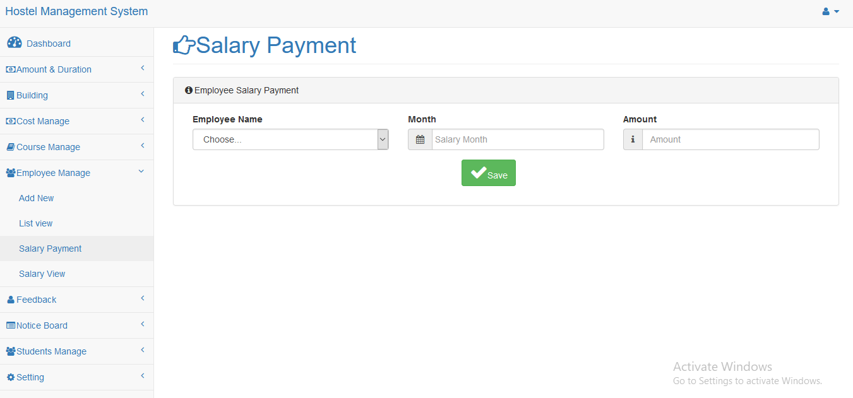

**Employee salary list**

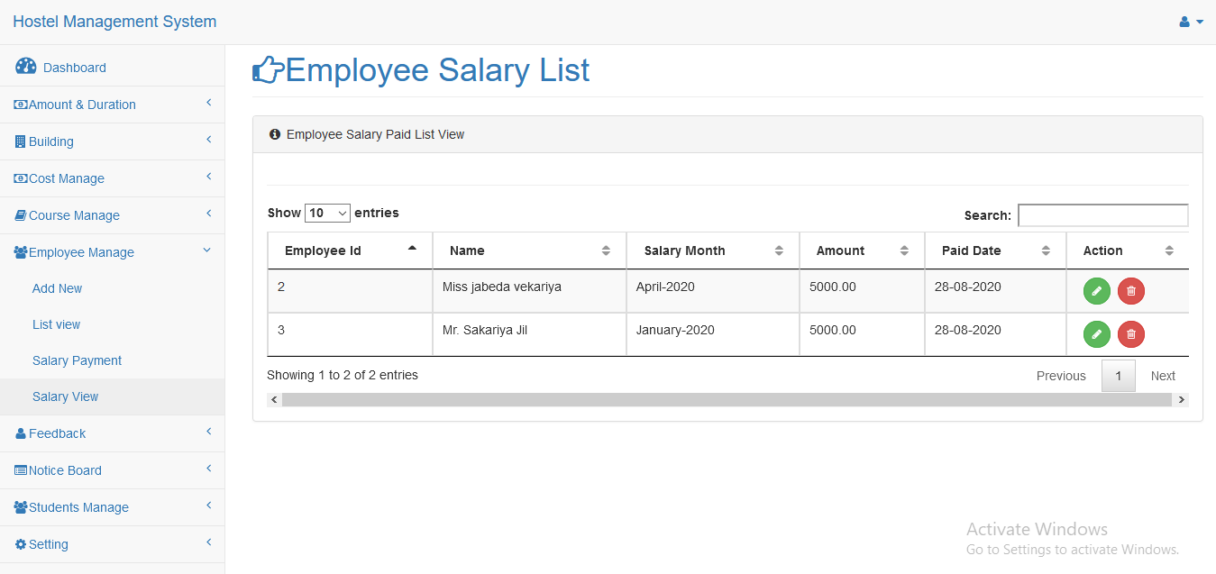

**Feedback**

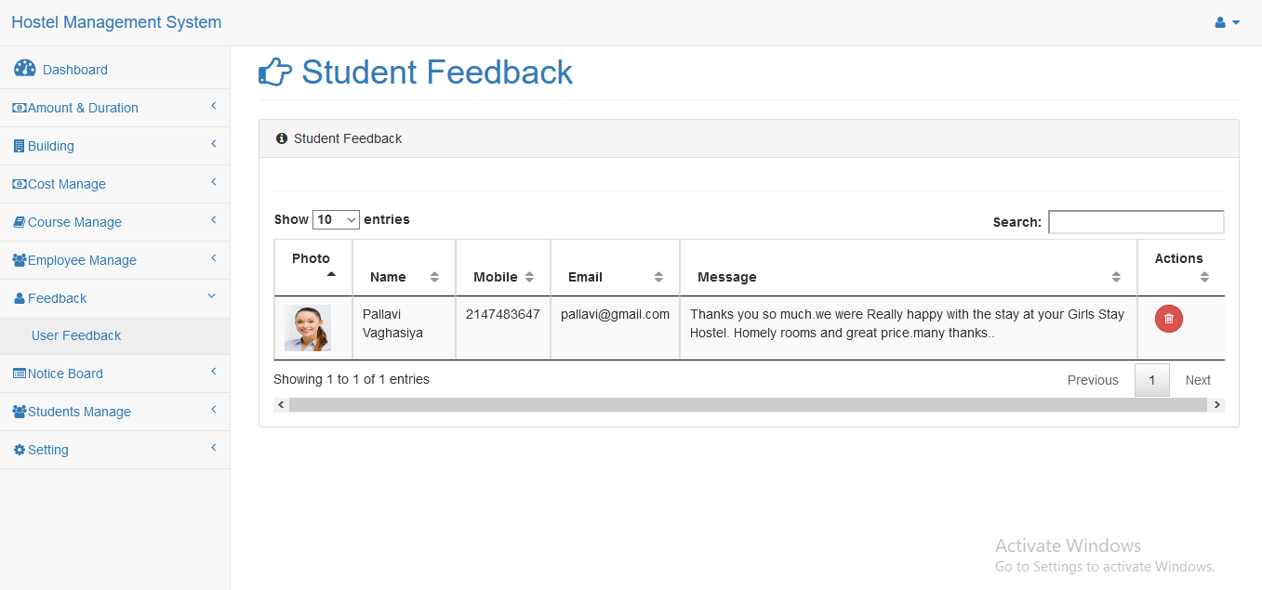

**Notice**

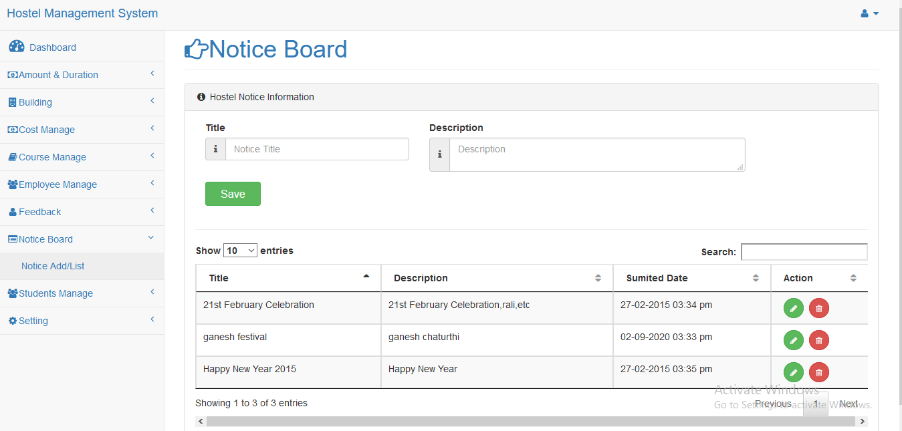

**Student register**

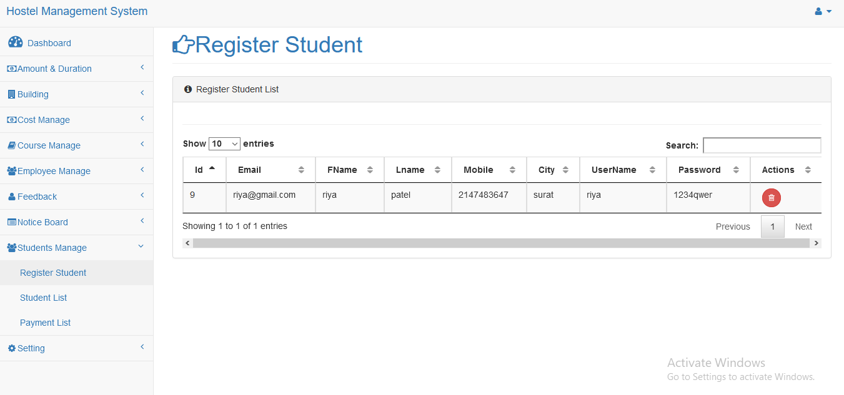

**Student list**

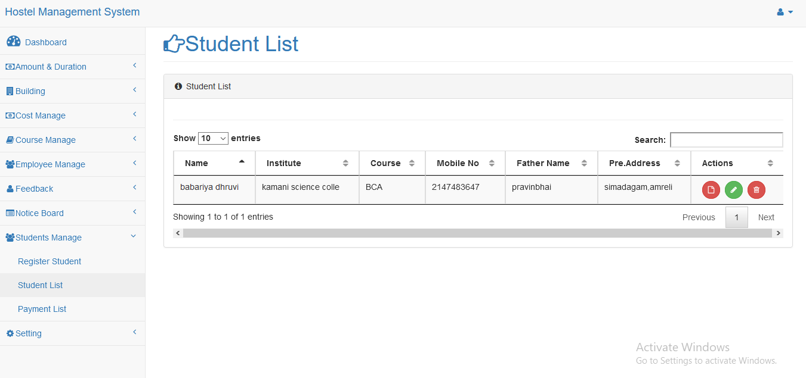

**Student payment**

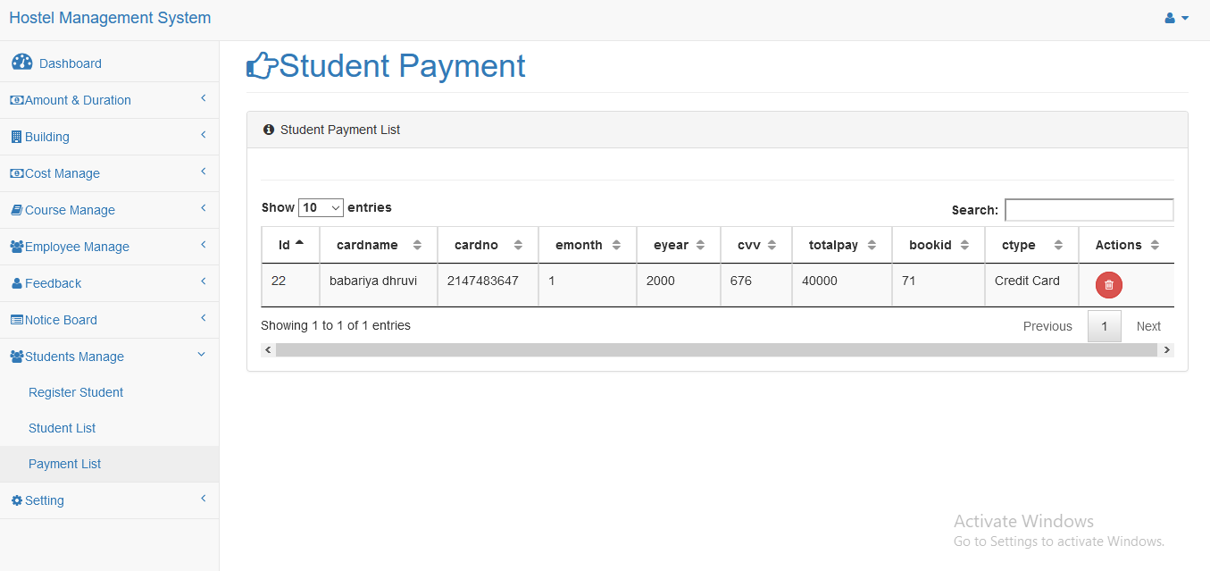

**Admin user**

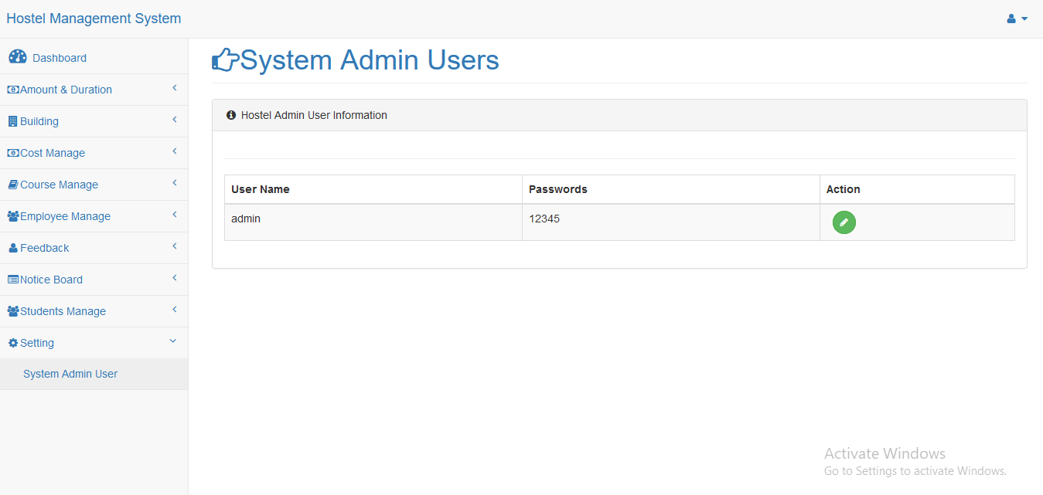

* **User**

**Home**

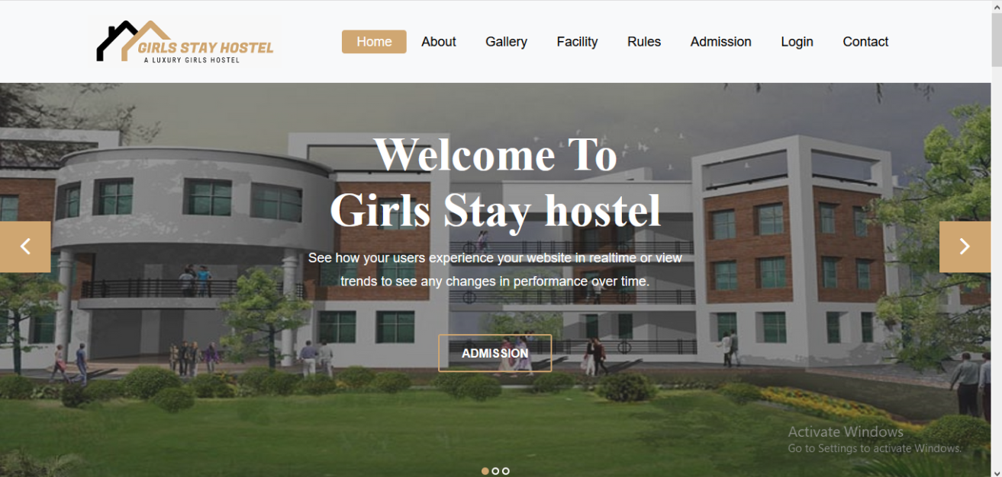

**About**

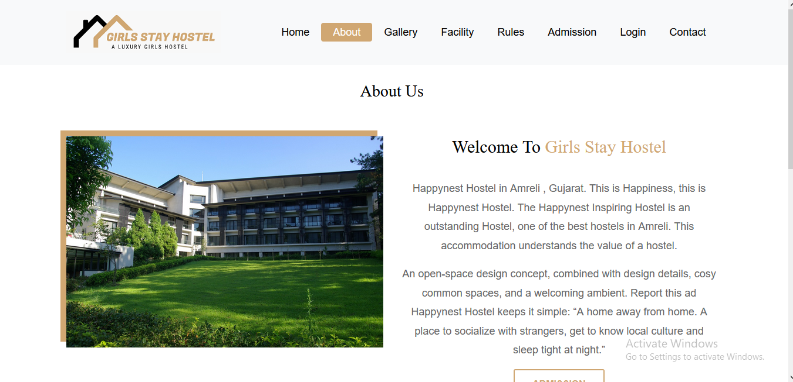

Gallery

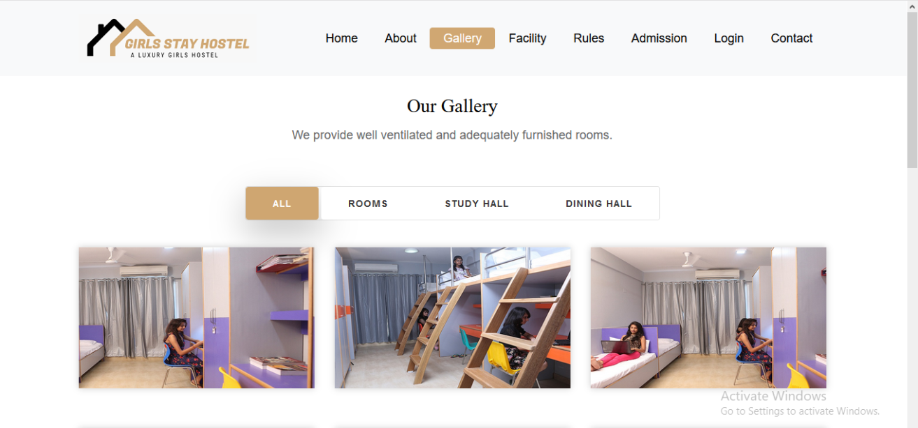

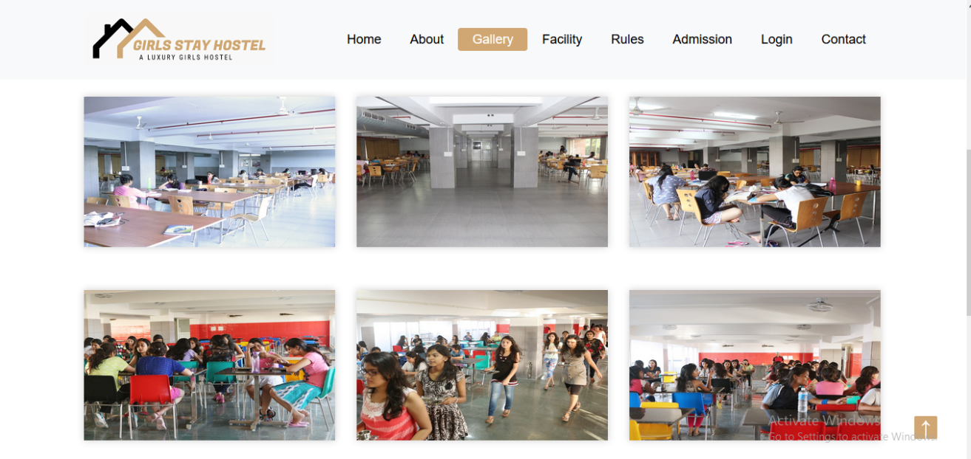

Facility

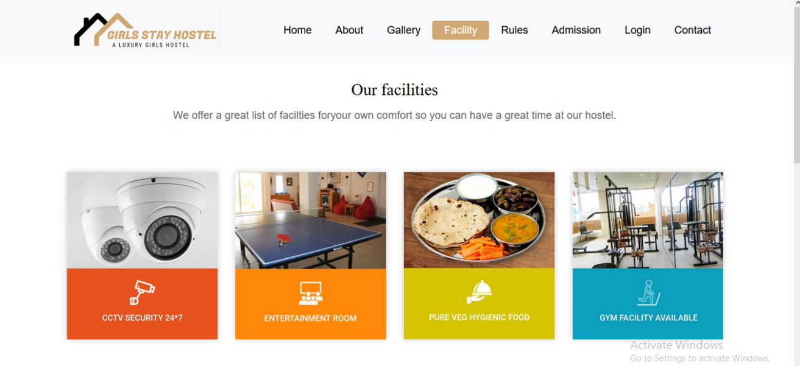

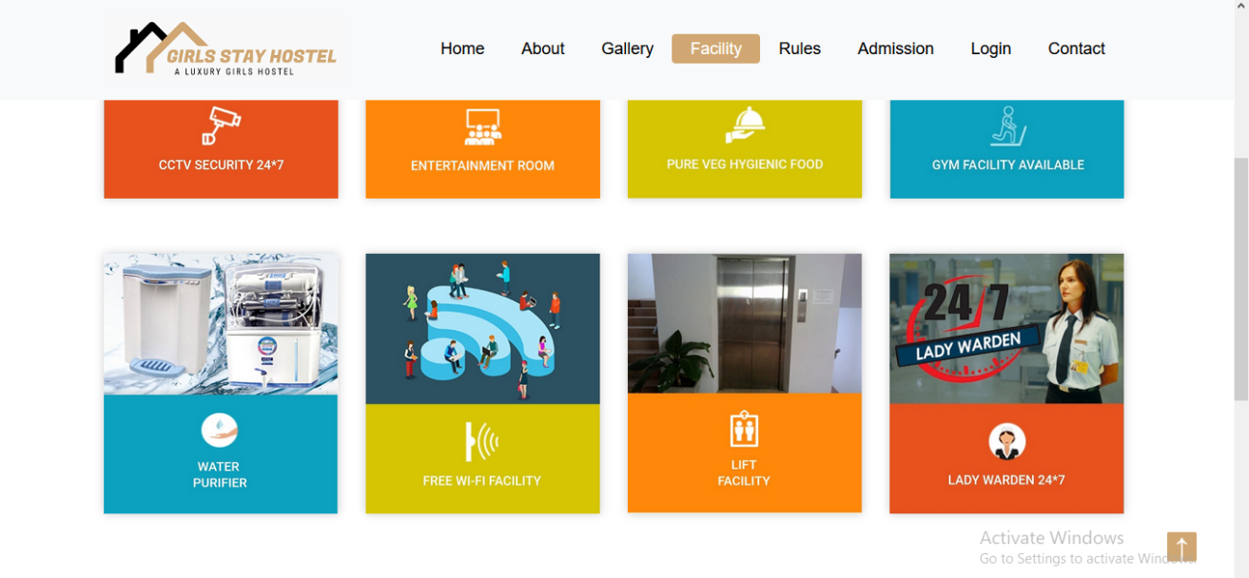

Rules

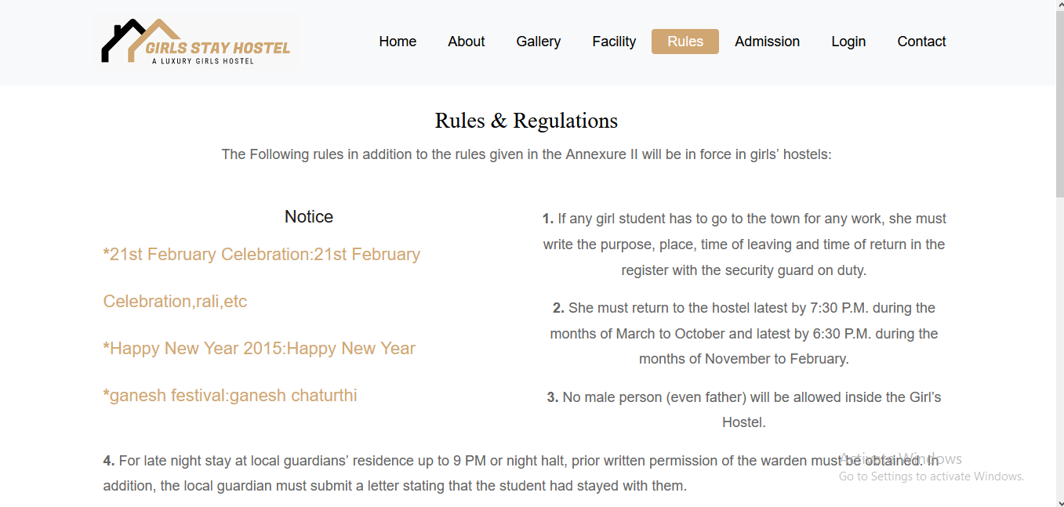

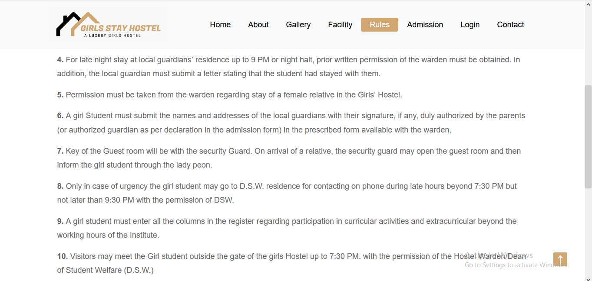

Contact

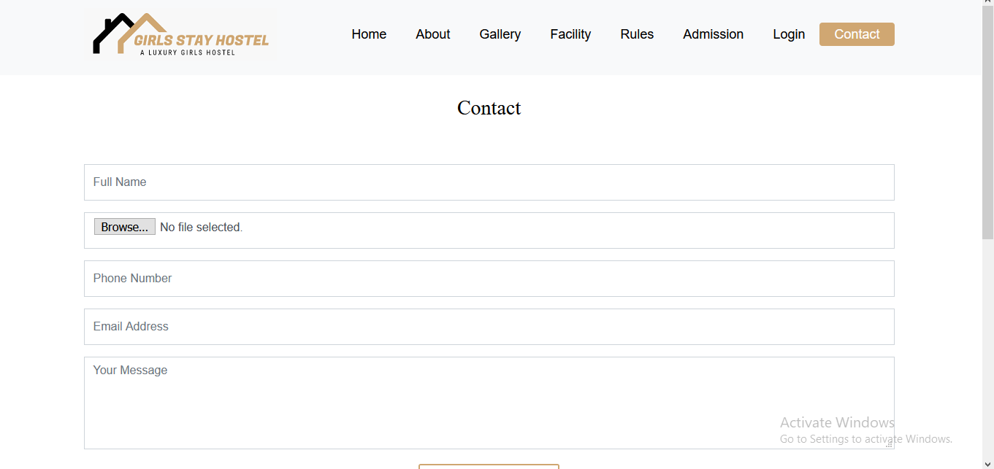 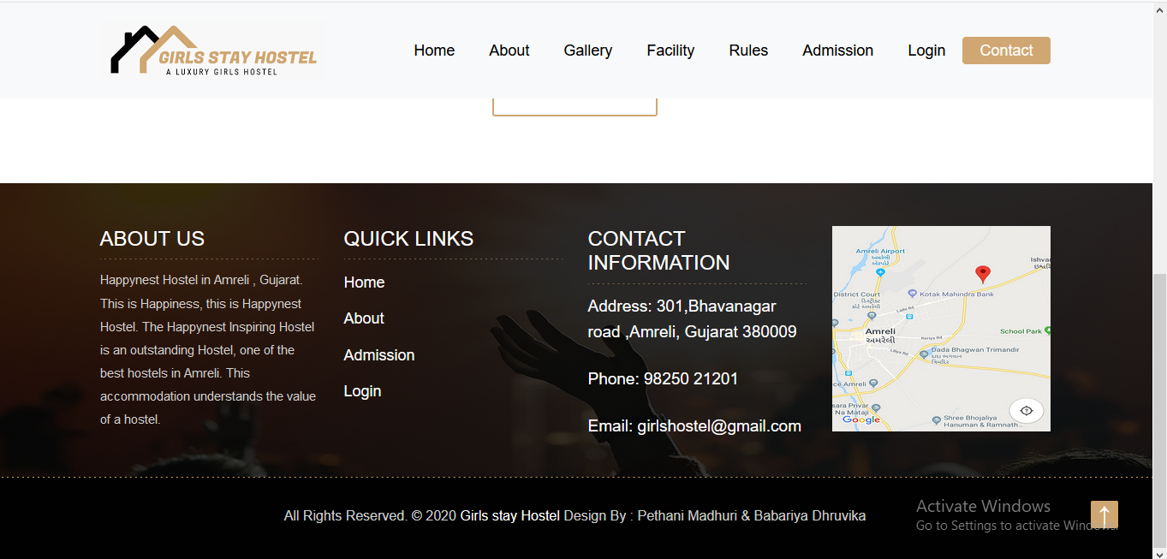

Register

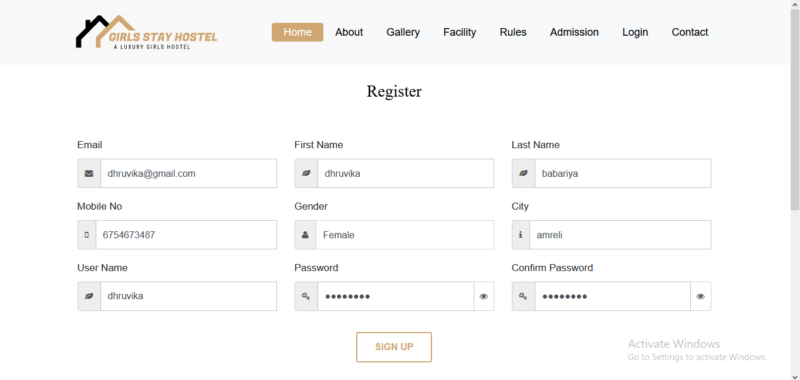

Login

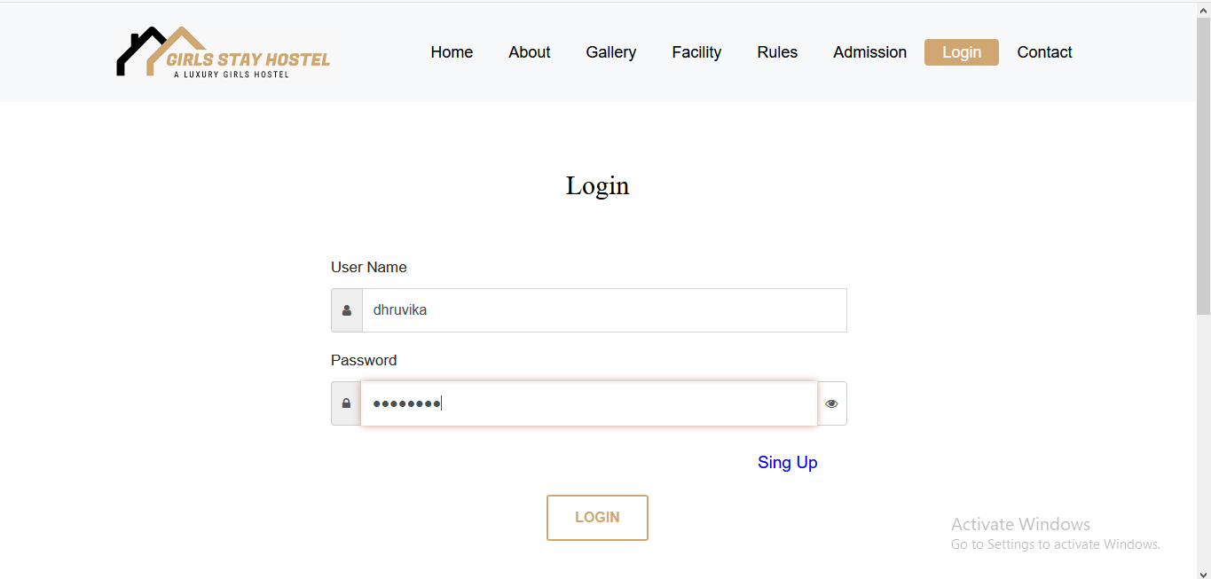

Admission

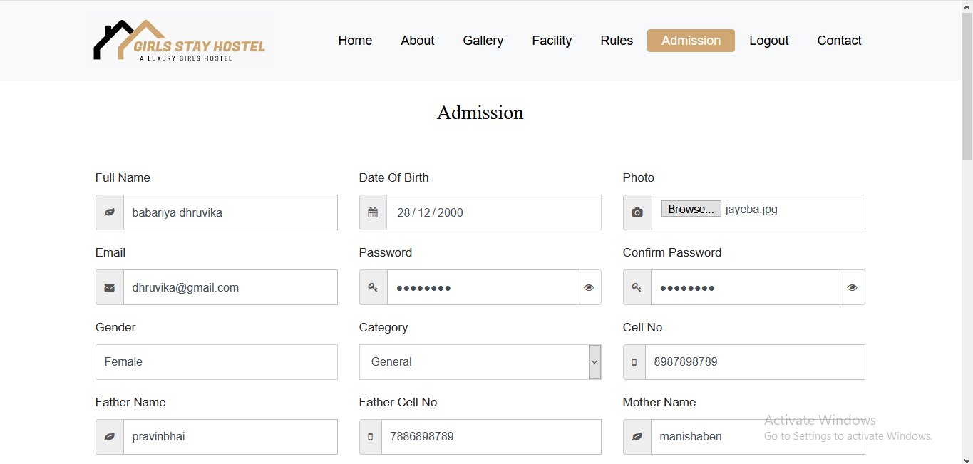

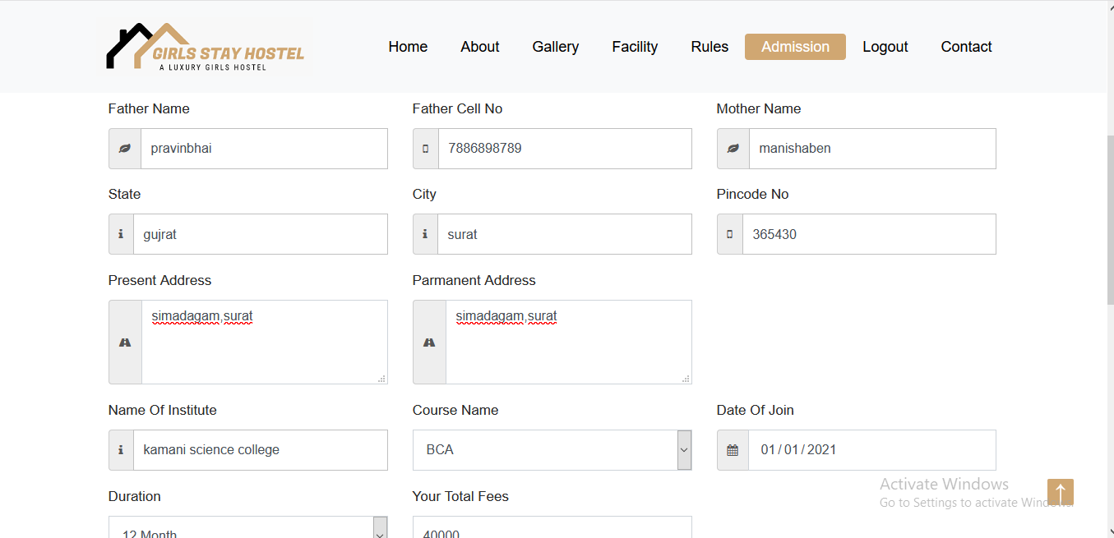

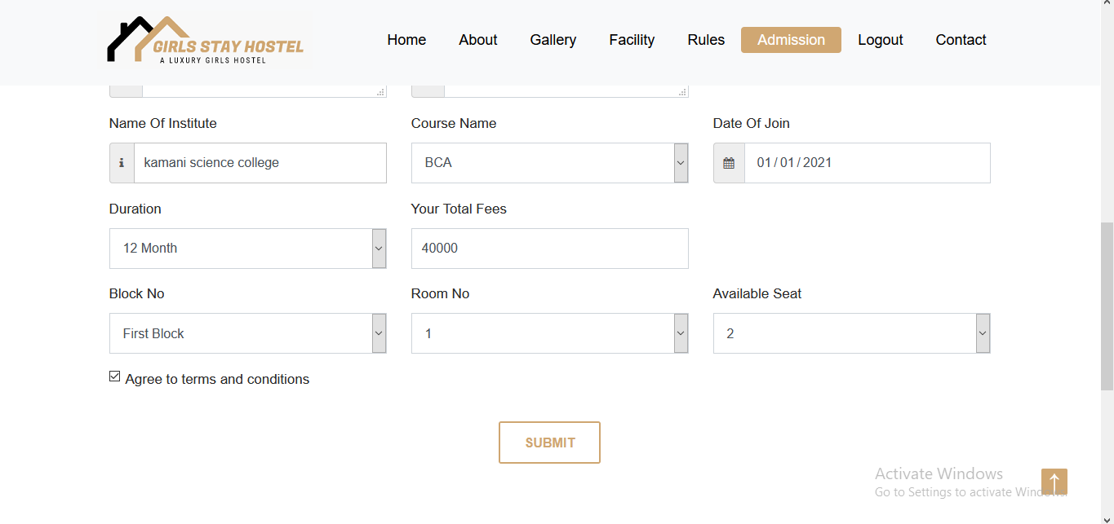

Payment

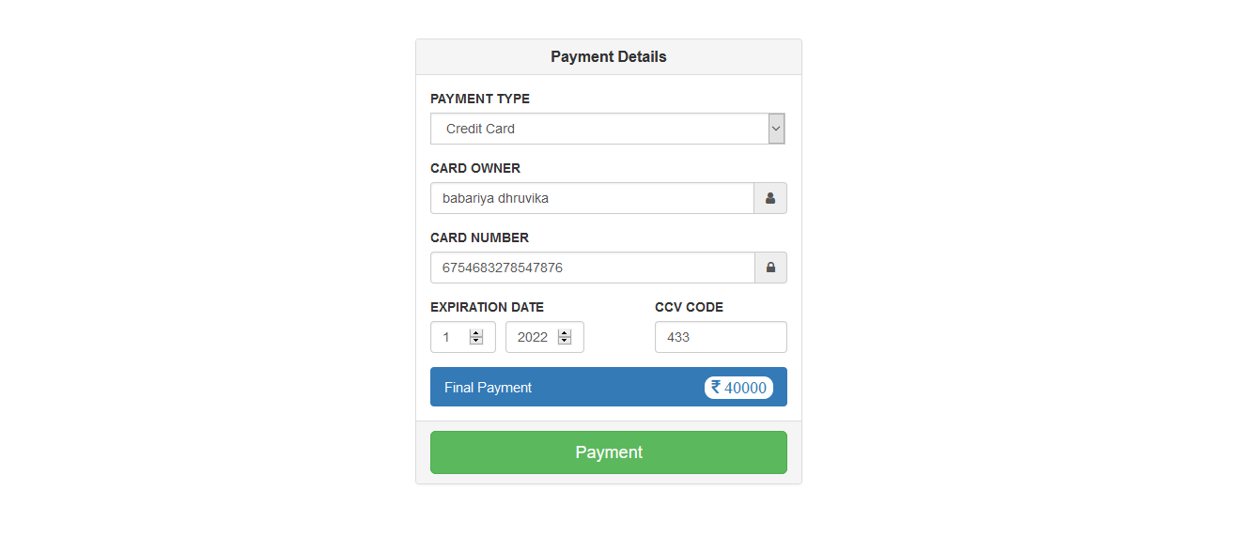

Receipt

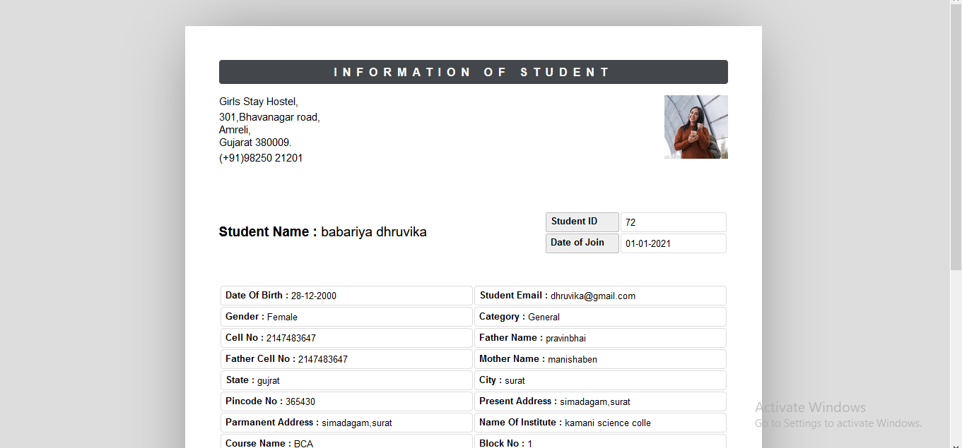

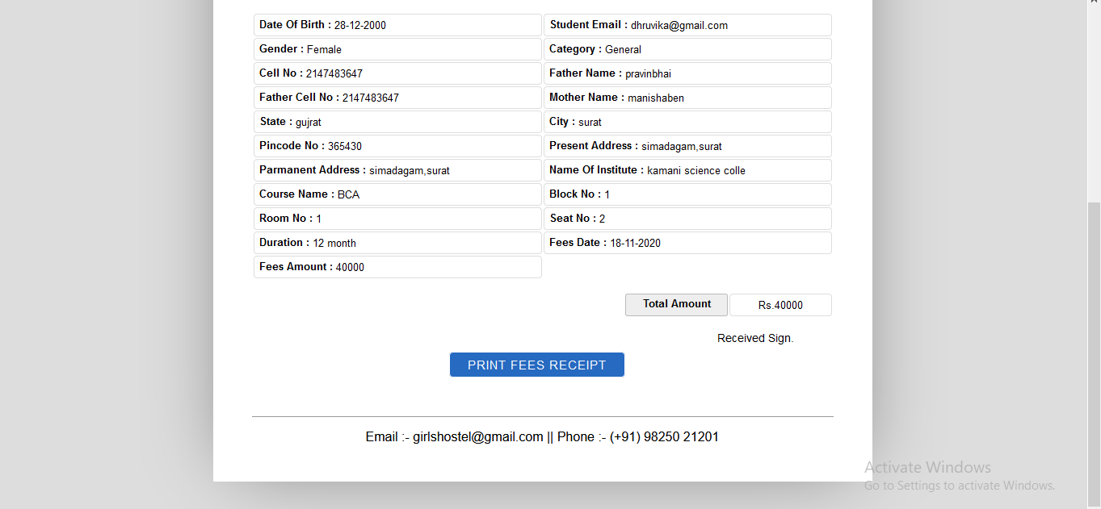

**Bibliogrphy**

1. [www.google.com](http://www.google.com)
2. [www.stackoverflow.com](http://www.stackoverflow.com)
3. [www.w3school.com](http://www.w3school.com)